North Carolina Department of Administration
North Carolina Council for Women and Youth Involvement
Application for State Grant Funds
Domestic Violence and Sexual Assault/Rape Crisis Centers

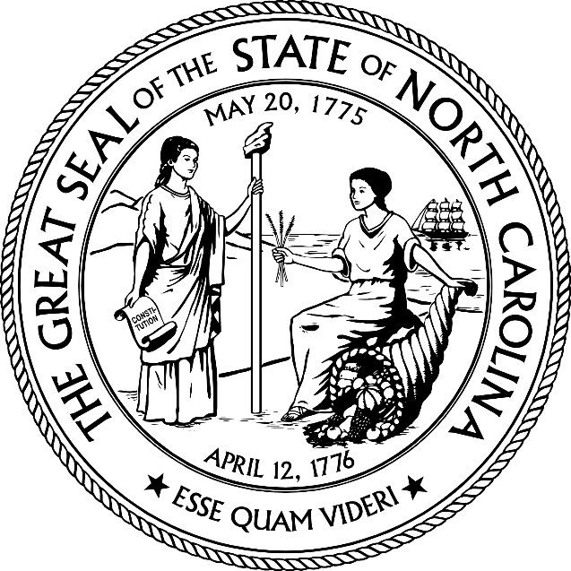

Program type:

County:
(Please use a separate application for each county)
Full Legal Name of Organization:
(as registered with the NC Secretary of State)
Agency is also known as:
Federal Tax Identification Number:
Date of Submission: Click or tap to enter a date.

Grant Application Submission Guidelines
Applicants must submit separate grant applications for each county and program. (Domestic Violence & Sexual Assault).
All information is required.
Domestic Violence and Sexual Assault Program Guidelines are available at:
https://ncadmin.nc.gov/advocacy/women/council-for-women-grants
Please refer to “Helpful Hints” handout when completing the grant application.
This handout indicates region office location.

Required Documents for Grant Application
Submit by mail to the designated Region Office:
☐One (1) Grant Application Part A.
☐One (1) Grant Application Part B Proposed Budget and Funding Sources Workbook.
☐One (1) copy of the current (dated no earlier than 07/2018) Governing Board list including names, contact information, terms, committee assignments and indication that the Finance Committee is chaired by the Treasurer.
☐One (1) copy of the Governing Board’s strategic plan and sustainability plan.
One (1) copy of each policy:
☐Conflict of Interest
☐Confidentiality
☐Non-Discrimination
☐Organizational Code of Conduct
☐Internal Controls
☐Recordkeeping (for Electronic and Manual Files)
☐Whistleblower
*Please note, NC CFW & YI does not accept responsibility for the sufficiency or the legality of the policies submitted. Sample policy templates are available in the Grants section of the NC CFW & YI website.

- GRANT APPLICANT INFORMATION

Organization type:
DUNS # if applicable (Data Universal Numbering System):
Organization’s fiscal year:
Year the organization was incorporated:
Year the organization obtained nonprofit status:
Month and year DV or SA program began operations:
Is program a subsidiary of another organization?
Current Executive Director: | As of:Click or tap to enter a date.
Name
E-mail Address
Telephone Number
Current Program Director (if applicable): | As of: Click or tap to enter a date.
Name
E-mail Address
Telephone Number
Administrative Office Physical Address:
Mailing Address, if different from above:
Days and Hours of Operation:
Administrative/Business Line: | Phone: Fax:
DV or SA Shelter/Program Physical Address (optional):
Mailing Address (if different from above):
Days and Hours of Operation:
Program Office/Facility Line(s): | Phone: Fax: Crisis Line:
Organizational Website Address:

Please indicate if the agency providing program services:
Owns the property where services will be provided:
Leases space where services will be provided:
Utilizes donated space where services will be provided:
Does your program offer multi-lingual services?
If so, please indicate language(s):
Does your program include a brick-and-mortar domestic violence shelter?
If yes, please indicate the number of bed spaces in your domestic violence shelter:
Please enter your board-approved organizational mission statement: (Answer box has 500-character limit)

II. PLAN FOR PROVISION OF BASIC CORE SERVICES
To be eligible to receive funds under N.C.G.S. § 50B-9 and/or § 143B-394.21, a domestic violence center and/or sexual assault or rape crisis center must offer all of the following services: a hotline, transportation services, community education programs, daytime services, and call forwarding during the night and it shall fulfill other criteria established by the Department of Administration. Service plan response boxes have a 300-character limit, position response boxes have a 125-character limit.

Please provide specific descriptions of how the domestic violence or sexual assault program will offer the following required services. In the third column, indicate only the positions to be funded by NC CFW & YI.

Basic Core Service | Specific Plan for Provision of Service | NC CFW & YI-Funded Positions That Will Provide Services
Hotline
Transportation
Community Education
Crisis Services
Shelter Services
Legal/Court Advocacy
Medical/Hospital Advocacy
Individual Counseling
Support Group

III. PLAN FOR PROVISION OF EXPANDED SERVICES (Only DV Applicants Complete This Section)

Expanded Service | Specific Plan for Provision of Service | NC CFW & YI-Funded Positions That Will Provide Services
Job Counseling
Job Training
/Placement
Financial Services
Health Education
Education Services

IV. PROGRAM GOALS/OBJECTIVES AND OUTCOMES

Projected Goals/Objectives and Outcomes
NC CFW & YI mandates three goals/objectives for both DV and SA grant recipients. Two goals/objectives are pre-determined, a third goal/objective must be elected by grant recipients. List three goals/objectives along with projected outcomes and evaluation methods that the organization will track during the fiscal year. Please do not list DV goals on your SA application or SA goals on your DV application. Each comment box below has a 250-character limit including spacing and punctuation.

For examples, refer to SMART Goal Guidelines included in the “Helpful Hints” Document.
S.M.A.R.T. Goals
Specific
- The goal must be specific enough for anyone to understand what you are trying to achieve.
  - What do you want to accomplish and why?
Measurable
- There must be some way to track progress on the goal, so you’ll know when it has been achieved.
Attainable
- The goal should be challenging, but it should also be realistic given the available resources.
Relevant
- The goal should be consistent with your mission, vision, values and other goals.
Time-Bound
- The goal should have a time frame for when it will be accomplished.

- Required for both DV and SA grant recipients:
  - Establish one goal/objective designed to promote victim services for targeted unserved, underserved or inadequately served populations.
  - Establish one goal/objective that involves client satisfaction with services.
Goal/Objective 1:

Projected Outcome:

Evaluation Method:

Goal/Objective 2:

Projected Outcome:

Evaluation Method:

Goal/Objective 3:

Projected Outcome:

Evaluation Method:

V. CLIENT OR COMMUNITY IMPACT SUCCESS STORY

Please share a success story from the current fiscal year corresponding to the type of grant application (i.e., DV-related story for DV application; SA-related for SA application). Success stories may highlight the impact of your program on an individual/family or on your broader community. Be sure to obtain explicit written, informed consent from clients if sharing a client-related story. Stories may be published, distributed and/or made publicly available on the NC CFW & YI website, social media outlets and/or annual report. The comment box below has a 500-character limit including spacing and punctuation.

VI. ORGANIZATIONAL CAPACITY

Provide information about the composition of your entire staff:
Number of staff: | Full-Time Part-Time Contract:
Gender: | Male Female Other
Race/Ethnicity: | Black/African American American Indian/Alaska Native Asian Native Hawaiian/Other Pacific Islander  Caucasian/White Hispanic/Latinx Other
Provide information about volunteers serving the DV or SA program that is the subject of this application:
Number of active volunteers:
Estimated financial value of volunteer support to your program:
Explain method used to calculate estimated value of volunteer support:

Provide information about the composition of your Board of Directors:
Number of people currently serving on the Board:
Gender: | Male Female Other
Age: | < 35 35-50 51-65 > 65
Race/Ethnicity: | Black/African American American Indian/Alaska Native Asian Native Hawaiian/Other Pacific Islander  Caucasian/White Hispanic/Latinx Other

- List current written memorandums of understanding or agreement (MOUs or MOAs) that your organization has in place, such as those with hospitals, local law enforcement and neighboring DV or SA programs, etc.
- List and describe how your organization coordinates and collaborates with community partners, task forces, committees, councils, response teams, and/or other entities to carry out the DV or SA program.
- Describe your organization’s process for making interagency referrals.
The comment box below has a 1000-character limit including spacing and punctuation.
VII. PERSONNEL
List all NC CFW & YI funded positions. For each position listed, indicate the entire salary/wage amount (not just the amount funded by NC CFW & YI, but the entire annual salary/wage amount) and the percentage of the entire salary/wage to be funded by each type of NC CFW & YI fund during the next fiscal year. If a position performs both DV and SA services and will be a proposed line item on both your DV and SA budgets, then that position should be listed in this section both on your DV grant application and your SA grant application. It is understood that percentages will not total to 100% unless NC CFW & YI is the sole funding source for a given position.

DV Grant:
Position Title | Entire Salary/Wage | % Funded by DV | % Funded by MLF | % Funded by DFF | Total % Funded by DV, MLF, & DFF

SA Grant:
Position Title | Entire Salary/Wage | % Funded by SA Grant

VIII. FUNDING AND FINANCIAL OVERSIGHT

List names, titles, experience, and financial background of those responsible for financial recordkeeping of NC CFW & YI funds:
Describe how financial records are maintained to ensure accountability of NC CFW & YI funds:

Explain how your organization maintains its chart of accounts:

Indicate software used to maintain chart of accounts:
Describe your organization’s check signing policies:

Indicate the date of your organization’s most recent financial audit, if applicable: | Click or tap to enter a date.
Indicate whether your organization practices cash or accrual accounting:
Describe how the Governing Board practices financial oversight:

Describe the Governing Board responsibilities with respect to fundraising, monitoring, and evaluation:

Does your organization maintain a three (3) month operating reserve fund?
If not, please explain:

Indicate what source(s) will be used to fulfill the required 20% match for DV and SA funds. The match must be unique to each program and must be locally-generated. Grants from state/federal sources may not be used as match. The match can be cash and/or in-kind.

IX. ORGANIZATIONAL POLICIES

Required Policies: The North Carolina Council for Women and Youth Involvement requires that grant recipients maintain each of the following policies. Each policy must be on file with NC CFW & YI. The policies and/or review and approval dates must be no earlier than April of last year (except for government entities). Policies that require signatures should be submitted with the required signatures. The North Carolina Council for Women and Youth Involvement does not accept responsibility for the sufficiency or the legality of the policies submitted.

Conflict of Interest Policy (must include management, employees, and board members)
Date policy became effective:Click or tap to enter a date.
Most recent board review date: Click or tap to enter a date.

Confidentiality Policy
Date policy became effective: Click or tap to enter a date.
Most recent board review date: Click or tap to enter a date.

Non-discrimination Policy
Date policy became effective: Click or tap to enter a date.
Most recent board review date: Click or tap to enter a date.

Organizational Code of Conduct Policy
Date policy became effective:Click or tap to enter a date.
Most recent board review date: Click or tap to enter a date.

Internal Controls Policy
Date policy became effective: Click or tap to enter a date.
Most recent board review date: Click or tap to enter a date.

Recordkeeping Policy
Date policy became effective: Click or tap to enter a date.
Most recent board review date: Click or tap to enter a date.

Whistleblower Policy
Date policy became effective: Click or tap to enter a date.
Most recent board review date: Click or tap to enter a date.

X. Signatures and Verification of Review of Grant Application

The issuance of grant funds is contingent upon a grant recipient fulfilling all responsibilities outlined and contained in the grant application, compliance with the terms of the contract documents, program guidelines as determined by The North Carolina Council for Women and Youth Involvement, reporting guidelines as determined by The North Carolina Council for Women and Youth Involvement, and the laws of the State of North Carolina.

By placing our signatures below, we hereby certify and confirm that this application provides an accurate and true statement regarding the purpose and obligation of our agency. We further certify and confirm that we have read, reviewed and understand all materials.

_______________________________________
Executive Director/Equivalent’s Printed Name

_______________________________________ ___________________
Executive Director/Equivalent’s Signature Date

______________________________________
Board Chair/Equivalent’s Printed Name

_____________________________________ ___________________
Board Chair/Equivalent’s Signature Date

