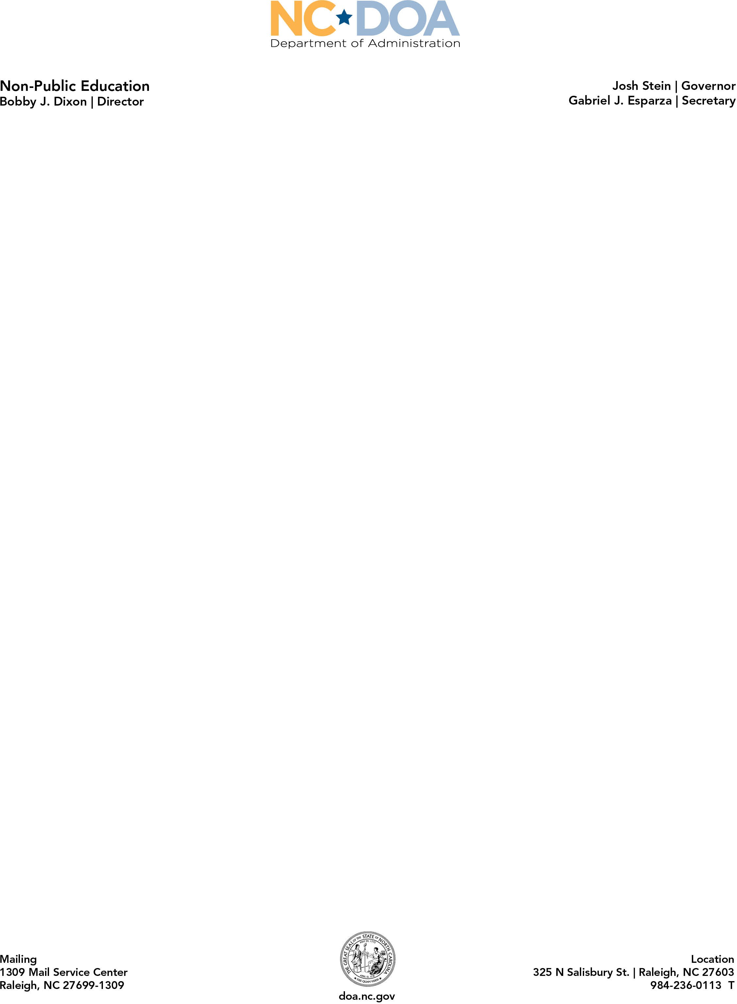

NC Private Schools K-12 Statewide Statistical History
The number of private schools and enrolled students is listed for the 1991-1992 through 2025-2026 school years. School and student numbers are based on data collected between July 1, 2025, and April 30, 2026.

School Year | Total Students | Total Schools
2025-2026 | 143,998 | 997
2024-2025 | 135,738 | 930
2023-2024 | 131,230 | 881
2022-2023 | 126,768 | 884
2021-2022 | 115,311 | 828
2020-2021 | 107,341 | 783
2019-2020 | 103,959 | 751
2018-2019 | 102,400 | 769
2017-2018 | 101,597 | 757
2016-2017 | 100,585 | 752
2015-2016 | 97,721 | 742
2014-2015 | 97,259 | 720
2013-2014 | 95,768 | 715
2012-2013 | 95,948 | 698
2011-2012 | 96,096 | 695
2010-2011 | 96,229 | 693
2009-2010 | 96,421 | 691
2008-2009 | 96,545 | 683
2007-2008 | 97,656 | 683
2006-2007 | 94,785 | 671
2005-2006 | 92,867 | 660
2004-2005 | 91,084 | 646
2003-2004 | 90,922 | 652
2002-2003 | 92,314 | 661
2001-2002 | 91,817 | 653
2000-2001 | 89,789 | 656
1999-2000 | 87,406 | 644
1998-1999 | 84,384 | 626
1997-1998 | 82,001 | 592
1996-1997 | 77,647 | 568
1995-1996 | 71,599 | 545
1994-1995 | 68,097 | 518
1993-1994 | 62,300 | 504

1992-1993 | 58,024 | 484
1991-1992 | 54,186 | 471

+ The 2020-2021 school year was the continuation year of the 2020 coronavirus pandemic, as such, some school enrollment data may be estimated.

