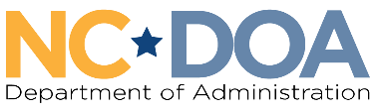
NC Commission on Accessibility: Language Access Committee Agenda
Thursday April 23, 2026
11:00 AM-12:00 PM
Virtual Meeting

Meeting Link: https://www.zoomgov.com/j/1600752608?pwd=Pqv3c0b6N6nASXvzogrMBCCGULgS9I.1
Meeting ID: 160 797 4768
Passcode: 502945

Welcome & Call to Order– 11:00 AM
Yolanda Adams, Commission Co-Chair

Attendance & Introductions – 11:05 AM
Jordan Etters, Program & Policy Coordinator, NC DOA

Committee Meeting Logistics Discussion – 11:15 AM
Jordan Etters, Program & Policy Coordinator, NC DOA

May Meeting Updates – 11:35 AM
Jordan Etters, Program & Policy Coordinator, NC DOA

Final Updates & Public Comments – 11:50 AM
Yolanda Adams, Commission Co-Chair

Meeting Adjourn – 12:00 PM

Next Meeting Date: TBD

