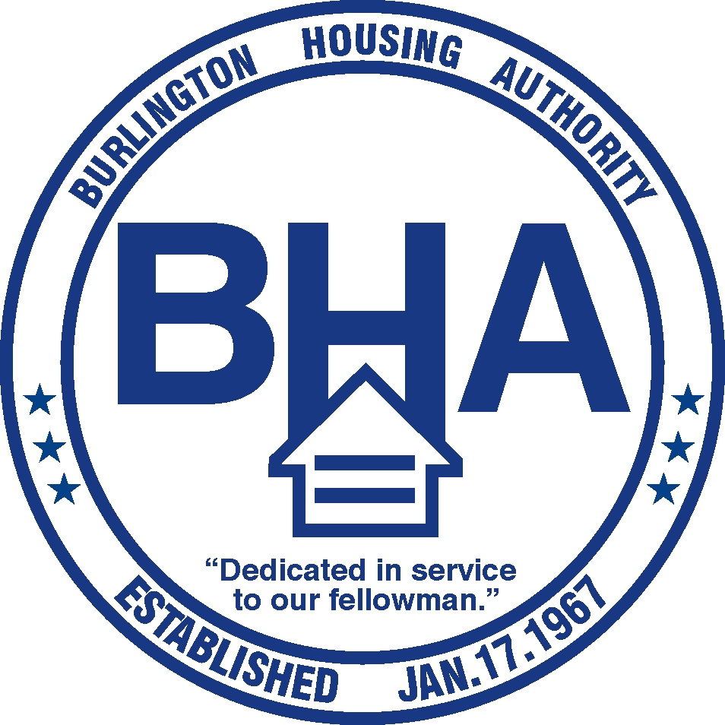

### **Eithiel Estes, REALTOR®/ Keller Williams Realty Western Steakhouse**

**Alamance Housing Committee North Park Farmers Market**

**Alamance County Committee on Civic Affairs CoIOperative - Graham**

**Burlington Masjid Alamance Peace Action**

**Alegria Tax&Accounting**

**Southern Alamance Family Empowerment (S.A.F.E.)**

#### **SUPPORTERS**

**Lori Thomas**, Assistant Professor of Social Work, UNC Charlotte.

**Ashley Clark**, Assistant Director, Institute for Social Capital, UNC Charlotte

**Justin Lane,** Social Research Specialist, Institute for Social Capital, UNC Charlotte

**Courtney Morton,** Housing & Homelessness Research Coordinator, Mecklenburg County

**Richard Gary,** Executive Director, Allied Churches of Alamance County, ACAC

**SPEAKERS**

* In 2016-2017, there were more than 500 school-aged children identified as homeless in Alamance
* 32% of children under the age of 5 in Alamance County are living below the federal poverty line
* 53% of the people in Alamance County spend more than 30% of their household income in rent
* Low wages, increasing rents and living costs are the main cause of homelessness. In North Carolina
* Counties have found significant savings when they provide housing to people who are homeless.

**EVENT ORGANIZER:**

**Alamance County Human Relations Commission** is a non-profit 501(c3) organization founded in 1966 to build a stronger, fairer community. Your donation will be tax-deductible.

Visit [**https://alamancehumanrelations.wordpress.com/**](https://alamancehumanrelations.wordpress.com/)to learn more about our mission and our work in the community

**Where?**

**When?**

Crump Village Education and Resource Center. 1209 Chandler Court Burlington, NC 27217

Thursday, September 14, 12:30 p.m. to 2:30 p.m. Lunch included. RSVP to [vanebravo25@yahoo.com](mailto:vanebravo25@yahoo.com) by Friday, September 8.

# Did you know?

Alamance County Human Relations Commission presents:

**Students Facing Homelessness**

A **free lunch-workshop** to learn about what some communities, including ours, are doing and can do to address homelessness

*Homeless is not hopeless*

Date: Sept. 7, 2017

Time: 12:30 p.m. to 2 p.m. p.m.lace: TBA

Save the date & support us!