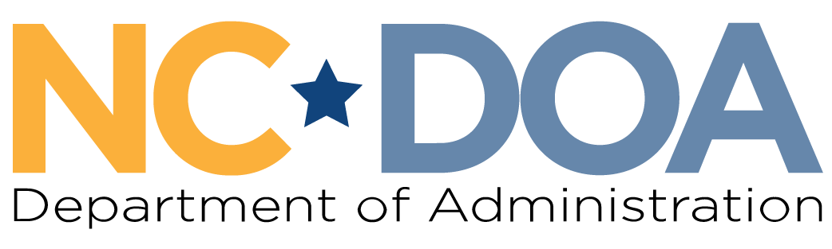
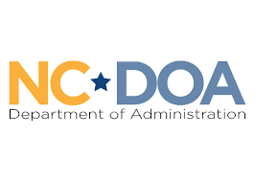

NC Martin Luther King Jr. Commission
North Carolina Department of Administration
___________________________________

Wednesday July 29, 2026
3:00-4:00 PM
Zoom Virtual Meeting

Meeting Link: https://www.zoomgov.com/j/1656713742?pwd=9EB950CMCFxS0Va0lesJzyywaIS22j.1
Meeting ID: 165 671 3742
Passcode: 003464
Meeting Minutes– Jordan Etters
Welcome & Call to Order – 3:07 PM
Marcus R. Bass, Commission Chair

Chair Bass welcomed everyone to the meeting and asked for all attendees to briefly remind everyone their name, affiliation, and share a personal update.

Attendance & Minutes – 3:14 PM
Jordan Etters, Policy & Strategic Planning Coordinator, NC DOA

Jordan Etters took attendance of present members based on the updates above. Afterwards, she called attendance for those who did not speak up.

Members Present: Marcus R. Bass, Dr. Tiffany Tuma, Patricia Levitin, Roosevelt Ethridge, Cheryl Hart, Phyllis Mack Horton, Mildred Christmas, & Jennifer Nehlsen
Others Present: Jordan Etters, Noelle S. Talley, & Leah Cattoti
Members Not Present: Dr. Warren Herndon, Dr. Charles Johnson, Laureen G. Jones, Resha Peregrino-Brimah, Walter Ferguson II, & Catherine Williamson-Hardy

The June 24th meeting minutes were approved by a majority quorum motion and formal vote.
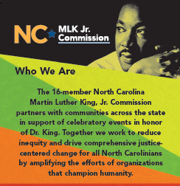
Int. Civil Rights Center & Museum Gala Recap – 3:17 PM
Commissioner Patricia Levitin

Commissioner Levitin shared a brief recap and highlights of the
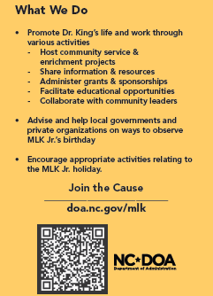July 18th International Civil Rights Center & Museum Annual Gala,
which the Commission sponsored and attended. She shared details
of the event and showed fellow members the event booklet and
Commission advertisement (below).

Commission members interested in obtaining one of the event
booklets can reach out to Commissioner Levitin directly.

Updates on the Office of Historically Underutilized Businesses – 3:21 PM
Noelle S. Talley, Deputy Secretary for Advocacy, NC DOA
Leah Cattoti, Policy Director, NC DOA

Noelle S. Talley and Leah Cattoti shared the following updates regarding the NC DOA Office for Historically Underutilized Businesses and the Governor’s Advisory Council on HUBs.
- In the recently enacted North Carolina state budget, Senate Bill 257, the HUB Office and coordinating Advisory Council were abolished.
  - All underlying statutory language and foundations were eliminated as well.
  - All agency staff positions dedicated to the service of the HUB Office were eliminated, and the agency is working to support those staff members in this transition.
  - The potential elimination first appeared in 2025 in legislative budget proposals, but somewhat unexpectedly appeared again.
- The only portion of the HUB Office that will remain active and within the Dept. of Administration is the Small Business Enterprise Program.
  - The agency is working with a transition team to move this program in the Division of Purchase and Contract.
  - DOA is committed to continuing to uplift HUBs and small businesses through this program.

Further NC DOA Agency Updates – 3:31 PM
Noelle S. Talley, Deputy Secretary for Advocacy, NC DOA
Jordan Etters, Policy & Strategic Planning Coordinator, NC DOA

Noelle S. Talley and Jordan Etters shared further agency updates to include:
- The enacted North Carolina state budget did include some encouraging funding allocations to areas like teacher salaries, law enforcement salaries, domestic violence/sexual assault programs, hurricane recovery efforts, childcare, housing, employee pay, etc.
  - On the other hand, the budget did eliminate a number of state job vacancies across state government; specifically, DOA is in the process of responding to the 20 vacant position reductions.
- The Commission received its annual allocation totaling $23,378.00 for Fiscal Year ’26-’27.
- The 2026 State of NC Internship Program concluded the week prior and was quite successful this year.
- The 2026 Lady Cardinal Mentorship class is completing their final week with a project presentation on the housing crisis at the end of the week.

Final Announcements & Public Comments – 3:34 PM
Marcus R. Bass, Commission Chair

Chair Bass shared with members that he is preparing to share updates on a proposed commemoration process for the Commission. He further reminded members to be aware of international travel security measures regarding devices.

Jordan Etters reminded members of the upcoming in-person meeting in August at the Historic Russell School in Durham County. As a follow-up, Chair Bass requested time at this meeting to revisit strategic efforts and a policy read on proposed constitutional amendments that will be on the voting ballot this year.

Jordan Etters shared she has followed up with the potential vendor for Commission name tags, with more details to come as soon as possible.

There were no public comments.

Meeting Adjourn – 3:41 PM

Next Meeting Date: Wednesday August 26th at 1:00 PM (Historic Russell School)

