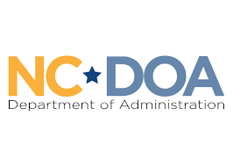
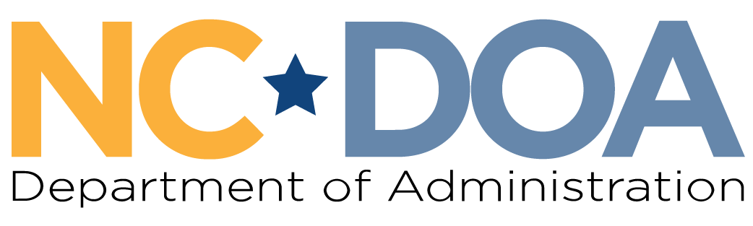

Martin Luther King Jr. Commission
North Carolina Department of Administration
___________________________________

Wednesday January 28, 2026
3:00-4:00 PM
Virtual Meeting

Meeting Link: https://www.zoomgov.com/j/1607956169?pwd=gNfVDc5lZ4uKmkcxiNVzIa24rGCmeZ.1
Meeting ID: 160 795 6169
Passcode: 157812
Meeting Minutes– Jordan Etters
Welcome & Call to Order- 3:05 PM
Marcus R. Bass, Commission Chair

Chair Bass welcomed everyone and called the meeting to order. The agenda was revised to include discussing the previously drafted statement on the changes of national park admittance on the MLK Jr. National Holiday.

Attendance & Minutes- 3:05 PM
Jordan Etters, Program & Policy Coordinator, NC DOA

Jordan Etters took attendance via a roll call vote. Of note, Commissioners Levitin and Ferguson were not sworn in.

Members Present: Dr. Tiffany Tuma, Catherine Williamson-Hardy, Dr. Warren L. Herndon, Marcus R. Bass, Phyllis Mack-Horton, Walter Ferguson Jr., Patricia Levitin, Roosevelt Ethridge, Cheryl Hart, & Laureen G. Jones
Others Present: Jordan Etters, Noelle S. Talley, & Eric Cole
Members Not Present: Jennifer Nehlsen, Resha Peregrino-Brimah, Dr. Charles Johnson, & Mildred Christmas

The December meeting minutes were approved by a majority quorum motion and formal vote.

MLK Service Day Project Recap- 3:07 PM
Marcus R. Bass, Commission Chair

Chair Bass introduced a conversation for members to share their experiences attending events in honor of the recent Martin Luther King Jr. Holiday, to include the State Employees Observance Program.

Commissioners Ethridge, Levitin, Herndon, Jones, Williamson-Hardy, Tuma joined Chair Bass in sharing about the events they attended and participated in to honor the Dr. King holiday.

Dr. Tiffany Tuma asked about guidance for when Commissioners wish to or are asked to speak on behalf of the Commission.

Chair Bass and Jordan Etters indicated the DOA team will be sharing some written guidance and are happy to discuss further at the February meeting if needed. Briefly, Jordan Etters stated that any representation of the Commission needs to be brought to the full Commission for approval.

Black History Month Activities Discussion- 3:23 PM
Marcus R. Bass, Commission Chair

Chair Bass initiated a discussion about upcoming events in honor of Black History Month. Members shared opportunities upcoming both in the meeting itself and within the meeting chat. Events and opportunities shared included:
- Sit In Movement - International Civil Rights Center & Museum
- African American Heritage Commission Black History Month Calendar
- Virginia Museum of Fine Arts - Giants: Art from the Dean Collection of Swizz Beatz and Alicia Keys
- 25th Annual African American Cultural Celebration
- Upcoming celebratory displays of African American artists throughout the DOA Albemarle Building

Branding & Apparel Check-In- 3:29 PM
Marcus R. Bass, Commission Chair

Chair Bass stated the Commission is able to begin discussing apparel and branding materials.

Noelle Talley added members can consider what item(s) they would like to have; how these items are to be paid for – Commission budget or by individuals who would like them; and what would be the most useful for members.

Chair Bass asked for an ad-hoc committee to follow-through on obtaining branding and apparel. Commissioners Levitin and Jones agreed to participate. Members will revisit at the February meeting.

Project/Partnership Proposal & Vote- 3:37 PM
Jordan Etters, Program & Policy Coordinator, NC DOA

Jordan Etters shared her screen to display a project proposal and partnership opportunity brought forth by the DOA Division of Women & Youth. The Commission was asked to participate in the 2026 State Youth Councils Conference in Raleigh from February 27th-March 1st. Further, the Commission, if it chooses to do so, can also sponsor lunch for the high school students in attendance.

Members briefly discussed and asked clarifying questions.

Jordan Etters will follow-up with members on the exact amount in the Commission’s budget.

A motion to approve participation in this event and to provide up to $500.00 (if there is $5,000.00 in the Commission’s budget) for lunch was made and received a second. A formal vote was had by a majority quorum and approved with no discussion or abstentions.

Statement on National Parks- 3:46 PM
Patricia Levitin, Commissioner

Chair Bass shared his screen to display the drafted statement addressing the recent changes to national park admissions on the national Martin Luther King Jr. Holiday.

A motion to approve the drafted statement was made and received a second. A formal vote was approved via majority quorum with no discussion or abstentions.

Noelle Talley indicated in the meeting chat the DOA team can assist with obtaining addresses for the NC Congressional delegation and others in DC.

Final Announcements & Public Comments- 3:49 PM
Marcus R. Bass, Commission Chair

Commissioner Herndon asked about the status of the State of NC internships.

Commissioner Mack Horton asked about the status of updates to the Commission’s webpage.

Noelle Talley and Jordan Etters responded:
- Webpage updates will be discussed with the DOA Communications team, and feasible updates will be shared for the Commission to further discuss.
- State of NC summer internship applications are being collected through Friday January 30th.

Dr. Tiffany Tuma shared she will be representing the Commission in serving on the Governor’s Advisory Committee for a Stronger NC. Related, Noelle Talley shared a brief background on this new Committee.

Meeting Adjourn- 3:57 PM

Next Meeting Date: Wednesday February 25th 1:00-3:00 PM (in-person)

