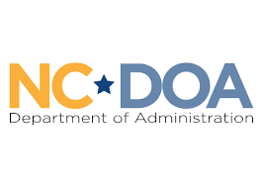
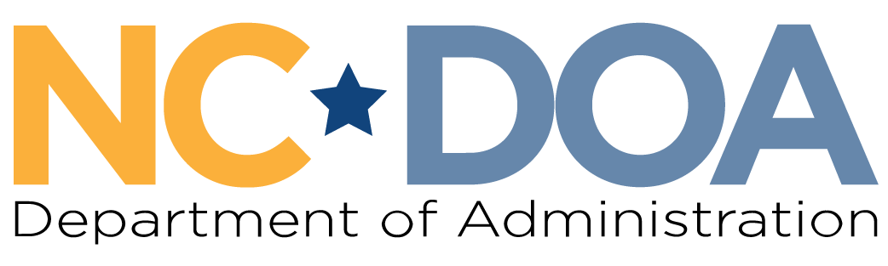

Martin Luther King Jr. Commission
North Carolina Department of Administration
___________________________________

Wednesday February 25, 2026
1:00-3:00 PM
Hybrid Meeting

Albemarle Building – Training Room #240
325 N. Salisbury Street
Raleigh, NC 27603

Meeting Link: https://ncgov.webex.com/ncgov/j.php?MTID=m894e61c9a1973f8687003cc66e78872a
Meeting ID: 2430 341 5408
Passcode: gqXjna82je9
Meeting Minutes– Jordan Etters
Welcome & Call to Order- 1:10 PM
Jordan Etters, Program & Policy Coordinator, NC DOA

Jordan Etters welcomed everyone to the meeting and indicated Vice Chair Tuma would be leading the meeting as Chair Bass was unable to attend.

Attendance & Minutes- 1:10 PM
Jordan Etters, Program & Policy Coordinator, NC DOA

Jordan Etters took attendance via roll call. Of note, Commissioners Levitin and Ferguson were not sworn in.

Members Present: Dr. Tiffany Tuma, Jennifer Nehlsen, Phyllis Mack Horton, Patricia Levitin, Walter Ferguson II, Mildred Christmas, Laureen G. Jones, Roosevelt Ethridge, Resha Peregrino-Brimah, & Dr. Charles Johnson
Others Present: Jordan Etters, Noelle S. Talley, & Leah Cattoti
Members Not Present: Marcus R. Bass, Catherine Williamson-Hardy, Cheryl Hart, & Dr. Warren L. Herndon

The February meeting minutes were approved by a majority quorum motion and formal vote.

NC DOA Agency Updates – 1:12 PM
Noelle S. Talley, Deputy Secretary for Advocacy, NC DOA

Noelle S. Talley shared brief agency updates to include:
- The Governor’s Advisory Council on Latino Affairs held its second quarterly meeting.
- The Committee for Stronger NC held its first meeting and is preparing for its first listening session. Vice Chair Tuma serves on this Committee on behalf of the MLK Jr. Commission.
- The Division of Indian Affairs is holding an Indian Child Welfare Gathering in March.
- The Division of Women & Youth is partnering the Office of the Governor to host a Women’s History Month policy roundtable and reception.
- DOA has a new Policy Director, Leah Cattoti.

Strategic Plan Annual Review & Discussion – 1:20 PM
Jordan Etters, Program & Policy Coordinator, NC DOA

Jordan Etters initiated the strategic planning review discussion for members and explained the documents shared with members for this review.

Members reviewed and discussed the following achievements and to-dos:
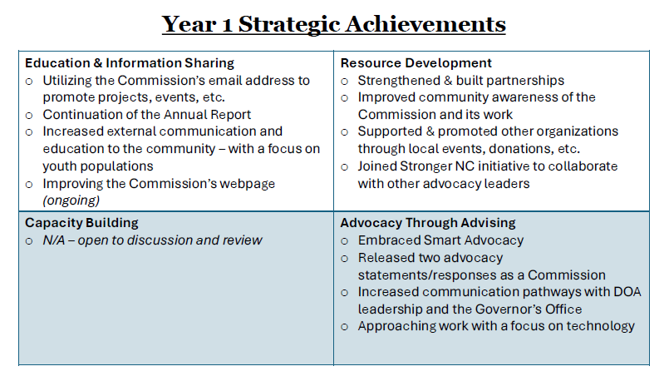

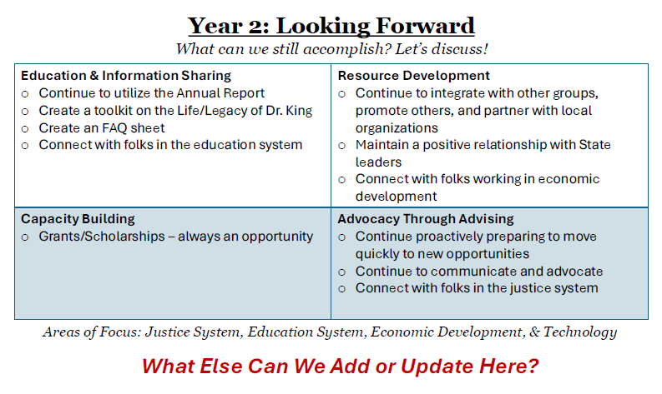

Commissioner Levitin followed up on the status of the Commission’s National Parks Statement.

A motion was made and a formal vote to approve sending the statement to the White House, the General Assembly, and to the US Congress (in the means DOA is able) was approved.

Sponsorships & Events Planning Discussion – 2:08 PM
Dr. Tiffany Tuma, Commission Vice Chair

Jordan Etters and Dr. Tiffany Tuma led a discussion on proposed spending, donation, and sponsorship opportunities. The following opportunities were discussed.
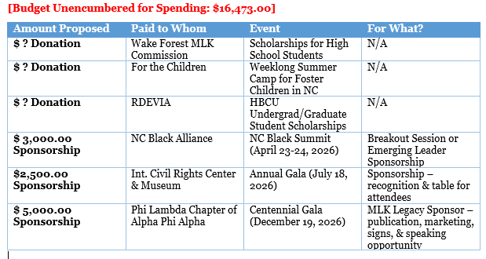

Upon discussion, members made two separate motions and took formal votes to approve the sponsorship opportunities below:
- $3,000.00 Community Partner Sponsorship – NC Black Alliance Black Summit (April 23-24th)
- $2,500.00 Sponsorship – Int. Civil Rights Center & Museum Annual Gala (July 18th)

Members agreed the remaining opportunities and others proposed during the meeting, along with any others shared after the meeting, will be reviewed at the March monthly meeting.

Meeting Locations Discussion & Spending Vote – 2:42 PM
Dr. Tiffany Tuma, Commission Vice Chair

Members briefly discussed the following proposed meeting locations for the May, August, and November in-person meetings:
- May
  - Perhaps at/near Freedom Park, to include a tour
- August 26th Meeting
  - Historical Russel Rosenwald School, Durham NC
  - $500.00 to reserve the space
  - Members will be able to do a site visit
- November 18th Meeting
  - International Civil Rights Center & Museum, Greensboro NC
  - $800.00 to reserve the space
  - Hybrid meeting capabilities
  - Members will be able to do a museum tour

A motion to approve spending and reservations for both the August and November meeting locations was made. A formal vote approved both via majority quorum.

Commission Apparel Progress – 2:50 PM
Pat Levitin, Commissioner

Commissioner Levitin lead a brief recap of progress and decisions to be made regarding Commission apparel. Further, she recommended a sweater, a shirt, and/or a tote bag.

Jordan Etters explained if members wish to utilize the Commission’s budget, then we will need to utilize a HUB-certified vendor, which we have three options for.

Recommendations for items and proposed costs will be shared at the next meeting for Commissioners to formally vote upon spending amount and if it’s coming out of the official budget.

Final Announcements & Public Comments – 2:53 PM
Dr. Tiffany Tuma, Commission Vice Chair

There were no final updates or public comments.

Meeting Adjourn- 2:54 PM

Next Meeting Date: Wednesday March 25th 3:00-4:00 PM (virtual)

