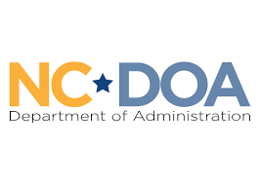
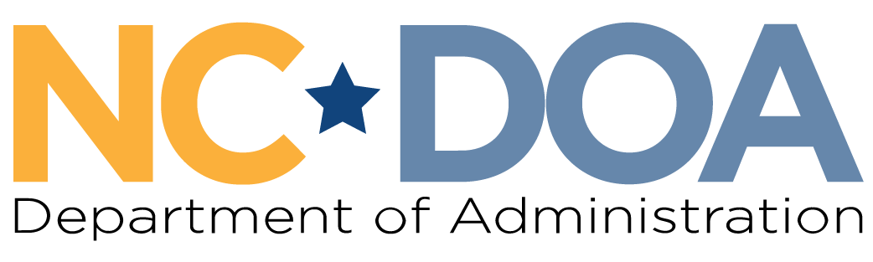

Martin Luther King Jr. Commission
North Carolina Department of Administration
___________________________________

Wednesday April 1, 2026
3:00-4:00 PM
Virtual Meeting

Meeting Link: https://www.zoomgov.com/j/1617661147?pwd=tANpwmT6teOdPbalFx9w0L1xhcotva.1
Meeting ID: 161 766 1147
Passcode: 277993
Meeting Minutes– Jordan Etters
Welcome & Call to Order- 3:00 PM
Marcus R. Bass, Commission Chair

Chair Bass welcomed everyone to the meeting and asked for a roll call of attendance.

Attendance & Minutes- 3:04 PM
Jordan Etters, Program & Policy Coordinator, NC DOA

Jordan Etters took attendance via roll call. Of note, Commissioners Levitin and Ferguson were not sworn in.

Members Present: Marcus R. Bass, Dr. Tiffany Tuma, Mildred Christmas, Patricia Levitin, Resha Peregrino-Brimah, Walter Ferguson II, Dr. Charles Johnson, Phyllis Mack Horton, Catherine Williamson-Hardy, Roosevelt Ethridge, & Jennifer Nehlsen
Others Present: Jordan Etters, Adrienne Nirde, Noelle Talley, & Eric Cole
Members Not Present: Dr. Warren L. Herndon, Cheryl Hart, & Laureen G. Jones

The February meeting minutes were approved by a majority quorum motion and formal vote.

African American Heritage Commission – 3:06 PM
Adrienne Nirde, Director, AAHC

Director Nirde introduced herself and shared her screen to display a presentation. She shared information regarding:
- The NC Dept. of Natural & Cultural Resources
- North Carolina Freedom Park
- The African American Heritage Commission
  - Purpose and membership
  - Programs/Events –
    - Freedom Roads
    - The NC Civil Rights Trail
    - Africa to Carolina
    - Green Books’ “Oasis Spaces”: African American Travel in NC (1936-66)
    - A Tale of Two Ships
    - MLK Jr. Holiday & Juneteenth Event(s)
    - Commission Newsletter

Chair Bass opened the meeting for questions and discussion on the AAHC and their work.

Members briefly discussed with Director Nirde, to include opportunities for specific follow-up with Commissioners Christmas and Levitin.

Spending & Sponsorship Discussion/Vote – 3:34 PM
Marcus R. Bass, Commission Chair

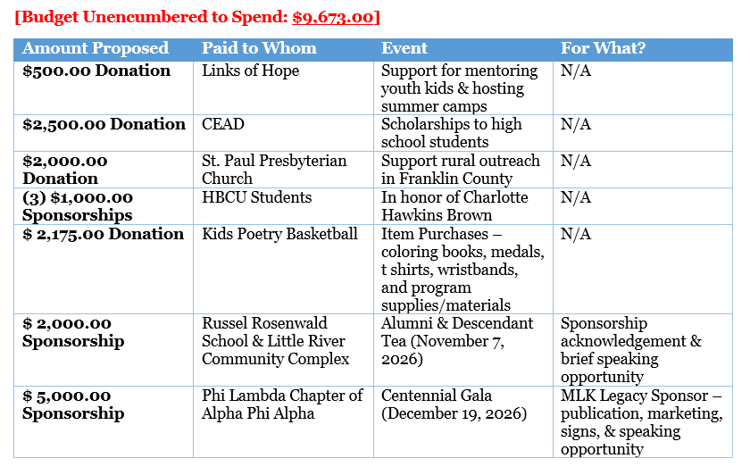Chair Bass entertained a discussion on the below proposed spending opportunities.

Vice Chair Tuma asked if Commissioners could elaborate and provide context on their proposed spending opportunities.

Commissioners Ferguson II and Levitin shared context for their proposed opportunities, to include Links of Hope, CEAD, Charlotte Hawkins Brown, and Kids Poetry Basketball.

Members agreed to reconsider the Russell Rosenwald Alumni Tea and the Phi Lambda Chapter Gala in July under the FY 26-27 budget.

Upon discussion, members made two separate motions, accompanied by two separate formal votes to approve the spending below as is, totaling $8,500.00. Both approved by majority quorum.
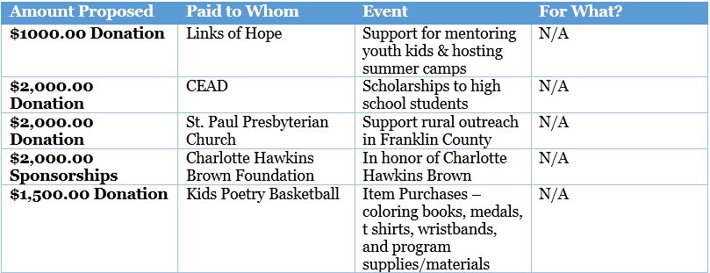

The remaining Commission budget for FY 25-26 is $1,173.00.

Final Announcements & Public Comments – 4:01 PM
Marcus R. Bass, Commission Chair

Vice Chair Tuma and Commissioner Ferguson II indicated the Governor’s Boards and Commissions webpage for this Commission is not updated, regarding current membership.

Jordan Etters indicated she has communicated these errors online to the appropriate people, and the updates should be made.

There were no public comments.

Meeting Adjourn- 4:03 PM

Next Meeting Date: Wednesday April 29th 3:00-4:00 PM (virtual)

