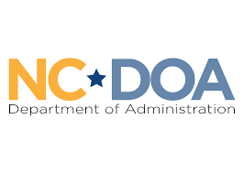
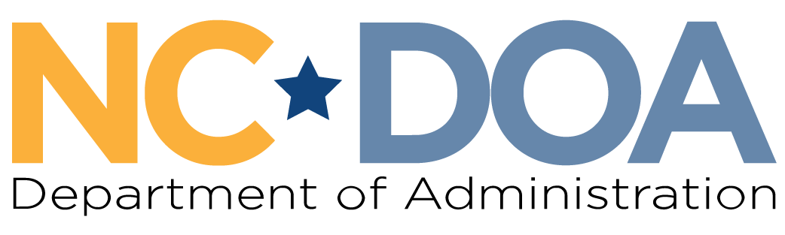

NC Martin Luther King Jr. Commission
North Carolina Department of Administration
___________________________________

Wednesday April 29, 2026
3:00-4:00 PM
Virtual Meeting

Meeting Link: https://www.zoomgov.com/j/1603582542?pwd=gIBhjvfbTpzucktVOaHD3pkvakwDja.1
Meeting ID: 160 358 2542
Passcode: 515479
Meeting Minutes– Jordan Etters
Welcome & Call to Order- 3:04 PM
Marcus R. Bass, Commission Chair

Chair Bass welcomed everyone to the meeting and asked for a roll call of attendance.

Attendance & Minutes- 3:05 PM
Jordan Etters, Program & Policy Coordinator, NC DOA

Jordan Etters took attendance via roll call. Of note, Commissioners Levitin and Ferguson were not sworn in.

Members Present: Marcus R. Bass, Dr. Tiffany Tuma, Walter Ferguson II, Catherine Williamson-Hardy, Mildred Christmas, Resha Peregrino-Brimah, Cheryl Hart, Patricia Levitin, Phyllis Mack Horton, & Dr. Charles Johnson
Others Present: Jordan Etters
Members Not Present: Dr. Warren L. Herndon, Jennifer Nehlsen, & Laureen G. Jones

The April 1st meeting minutes were not approved by a majority quorum motion and formal vote.

Budget & Spending Discussion – 3:06 PM
Marcus R. Bass, Commission Chair

Chair Bass initiated a conversation about the standing budget of the Commission and asked Jordan Etters to provide an update.

Jordan Etters shared her screen to display the following spending information for Fiscal Year ’25-’26, which ends in June. Members briefly discussed and asked clarifying questions.
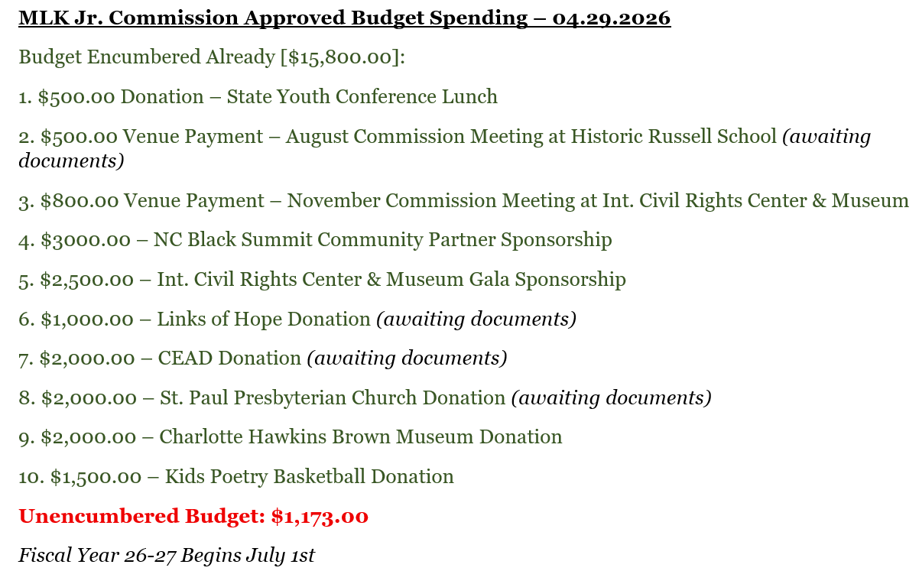

Commission Apparel Discussion – 3:18 PM
Marcus R. Bass, Commission Chair

Chair Bass began a discussion on acquiring Commission-specific apparel.

Commissioner Peregrino-Brimah suggested considering name tags/lapels as they are easier to place on any piece of clothing and could be utilized at any event where the Commission is being represented.

Jordan Etters indicated a need to clarify with the Governor’s boards and commissions’ team on what precedents exist in Commission-specific items for members.

Member briefly discussed obtaining name tags, apparel, or both.

A motion to approve purchasing name tags/lapels with Commission funding was made and received a second. A formal vote to approve this spending was held via majority quorum. Approval.

Open Discussion – 3:27 PM
Commissioners

Commissioner Peregrino-Brimah shared the proposal below for sponsorship consideration:
- The 2026 Frederick Douglass Foundation of NC Juneteenth Celebration
  - June 20th from 6:00 PM-8:00 PM in Raleigh, NC
  - $600.00 Table Purchase (8 seats)
  - Members interested included Commissioners Peregrino-Brimah (and guest), Horton, Bass, Williamson-Hardy, Ethridge, & Christmas

A motion to approve was made and received a second. A formal vote to approve this sponsorship/spending was held via majority quorum. Approval.

Commissioner Levitin updated members on the new time for the July International Civil Rights Center & Museum Gala. Further, interested members included Commissioners Levitin, Peregrino-Brimah (and guest), Ferguson II (and guest), Williamson-Hardy, Mack Horton, and Bass.

Commissioner Mack Horton shared a recap of her experience attending the 2026 NC Black Summit hosted by the NC Black Alliance. Further, Phyllis shared a recent experience in touring the 16th Baptist Street Church and Kelly Ingram Park in Birmingham, Alabama,

Members briefly discussed bringing an expert to the May in-person meeting to provide background, information, and recent updates on the Leandro vs. the State of North Carolina court case.

Members briefly discussed the below items:
- Senate Bill 214
- The concerns and coordinating policy changes around the use of water and water tables to support data centers
- The United State Supreme Court ruling in Louisiana vs. Callais et al.
- The upcoming vote to take place on the North Carolina version of the SAVE Act.

Final Announcements & Public Comments – 3:50 PM
Marcus R. Bass, Commission Chair

There were no further updates or public comments.

Meeting Adjourn- 3:50 PM

Next Meeting Date: Wednesday May 27th at 1:00 PM (in-person)

