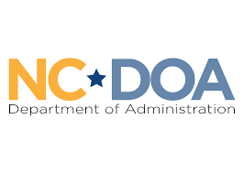
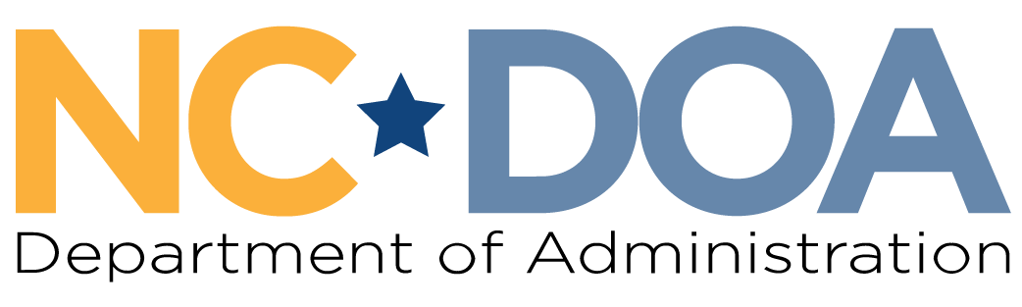

NC Martin Luther King Jr. Commission
North Carolina Department of Administration
___________________________________

Wednesday May 27, 2026
1:00-3:00 PM
In-Person Meeting

Albemarle Building – Training Room #245
325 N. Salisbury Street
Raleigh, NC 27603

Meeting Link: https://ncgov.webex.com/ncgov/j.php?MTID=ma31bd4a3424a7ee159b02853a0f8f8b6
Meeting ID: 2428 991 8219
Passcode: d6ECFt2XuR4
Meeting Minutes– Jordan Etters
Welcome & Call to Order- 1:12 PM
Marcus R. Bass, Commission Chair

Chair Bass welcomed everyone to the meeting and asked for a roll call of attendance.

Attendance -1:13 PM
Jordan Etters, Program & Policy Coordinator, NC DOA

Jordan Etters took attendance via roll call. Of note, Commissioners Levitin and Ferguson were not sworn in.

Members Present: Marcus R. Bass, Dr. Tiffany Tuma, Catherine Williamson-Hardy, Phyllis Mack Horton, Roosevelt Ethridge, Mildred Christmas, Dr. Charles Johnson, Cheryl Hart, Laureen G. Jones, & Patricia Levitin
Others Present: Jordan Etters, Noelle S. Talley, Leah Cattoti, Lauren Macemore, Anhuar Castaneda, Jennifer Rifkin
Members Not Present: Jennifer Nehlsen, Dr. Warren L. Herndon, Resha Peregrino-Brimah, & Walter Ferguson II

The April 1st and April 29th meeting minutes were approved by a majority quorum motion and formal vote.

Leandro vs. State of North Carolina Presentation – 1:14 PM
Jennifer Rifkin, Sen. Policy & Research Coordinator, Public School forum of NC

Jennifer Rifkin introduced herself and presented a PowerPoint presentation on behalf of the Public School Forum of North Carolina. Jennifer presented specifically educational funding in the state, the Leandro vs. State court case, and current policy and budget updates for member consideration.

Members briefly asked questions and made brief statements throughout the presentation. The below was asked about and/or discussed:
- The cost/spending breakdown and funding determinations for schools between the federal, state, and local governments.
- The constitutional requirement for North Carolina to provide a specific percentage of public-school funding.
- The Local School Finance Study and rural versus urban county disparities.
- The correlation or connection between funding and school/student performance.
- Recent funding cuts have been impacted by policy decisions.
- Relevant turnover in both the General Assembly and NC Supreme Court in the last 3 decades.
- The Opportunity Scholarship Program, private school vouchers, charter schools, and decreasing private school affordability.
- The racial and socio-economic impacts of efforts to defund, not support, and derail public schools.
- The forthcoming NC General Assembly budget and recently released agreements to include increases to teacher salaries and bonuses, proposed impactful tax cuts, and potential changes to the state constitution.

2026 Events & Projects Check-In – 2:08 PM
Marcus R. Bass, Commission Chair

Members briefly reviewed the current status of the Fiscal Year 2025-2026 Commission budget and encumbered spending (below).
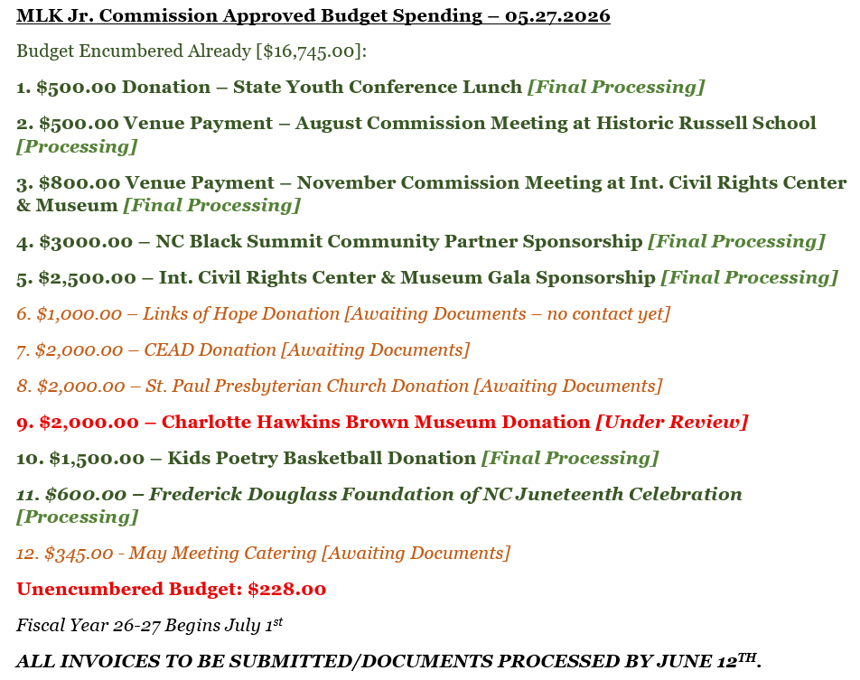

Lastly, members briefly reviewed the 2026 Commission Events Calendar and discussed upcoming events and meetings (below).
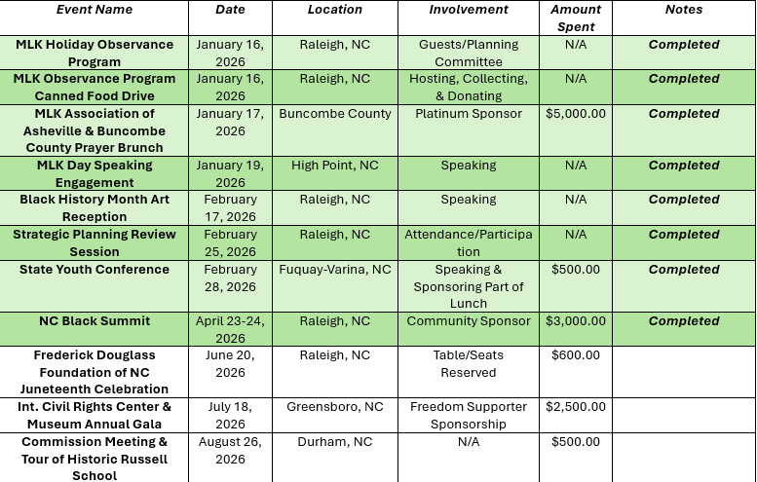

NC Dept. of Administration Updates – 2:17 PM
Jordan Etters, Policy & Strategic Planning Coordinator, NC DOA
Noelle S. Talley, Deputy Secretary for Advocacy, NC DOA

Jordan Etters and Noelle S. Talley shared the following agency updates:
- The legislative budget process is underway, so the DOA legislative liaison is keeping track of agency interests and requests.
- The newly established NC Commission on Accessibility held its first gathering in early May, and members will focus on four pillars of statewide accessibility (digital access, communications, language access, and physical access).
- The State of NC Internship Program for the summer has begun and interns have joined the agency.
  - Two interns from Secretary Esparza’s office introduced themselves.
  - Within Governor Stein’s Budget Proposal for Fiscal Year 2026-2027, there is a request for funding allocated to support 100 more intern positions next summer.
- The Office of Historically Underutilized Businesses is hosting a Capital Area Small Business Summit on June 22nd.

Commission Name Tag Discussion & Vote – 2:24 PM
Marcus R. Bass, Commission Chair

Chair Bass led a discussion on options for Commission name badges based on a number of options from a certified HUB-vendor. Members discussed the following:
- Name badges should include Commissioners names and the Commission official logo.
- Name badges should be turned in after Commissioners finish their service to NC DOA staff.
- The Savannah Metal Name Badge from Express Yourself Promotional Products, at $11.53 per badge, is the unanimous favorite.

A motion to approve the spending to obtain the above name badges for Commissioners was made and received a second. A formal vote was held via majority quorum. Approval.

Final Announcements & Public Comments – 2:28 PM
Marcus R. Bass, Commission Chair

There were no further updates or public comments.

Meeting Adjourn- 2:30 PM

Next Meeting Date: Wednesday June 24th at 3:00 PM (virtual)

